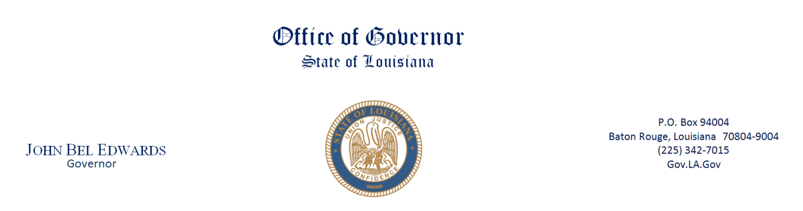

AGENDA

JUVENILE JUSTICE REFORM ACT IMPLEMENTATION COMMISSION
July 7, 2023
10:00 am - 12:00pm

Governor’s Pressroom
4th Floor State Capitol

Senator Royce Duplessis, Chair
Ms. Gina B. Womack, Vice Chair

- Welcome/Call Meeting to order Senator Royce Duplessis, JJRAIC Chair
- Roll call Amaiya Ewell
- Approval of November Minutes JJRAIC members
- Reports Mr. Otha “Curtis” Nelson, Deputy Secretary
Louisiana Office of Juvenile Justice

Dr. Melanie Washington, Executive Director
Louisiana Children’s Cabinet

Dr. Cade Brumley, State Superintendent
Louisiana Department of Education

V. Remarks Ms. Elizabeth Ryan, Administrator
U.S. Office of Juvenile Justice and Delinquency Prevention

Mr. Simon Gonsoulin, Consultant
Office of Juvenile Justice and Delinquency Prevention
VI. Next Steps:
a. Confirm next meeting date:
VII. Public Comments
VIII. Adjournment

YOUTUBE LIVE STREAM: https://www.youtube.com/channel/UCNcGodSlBUhLcOmotMk7OEw/featured

